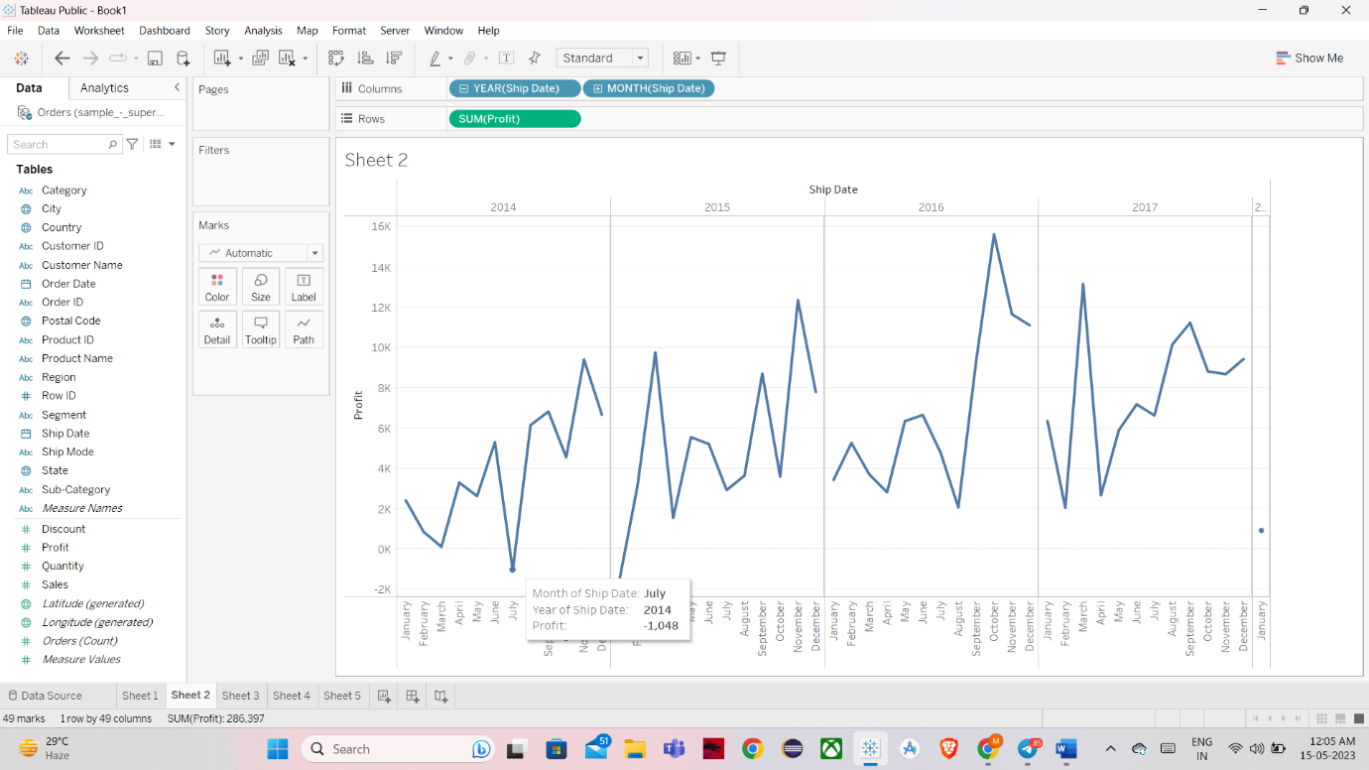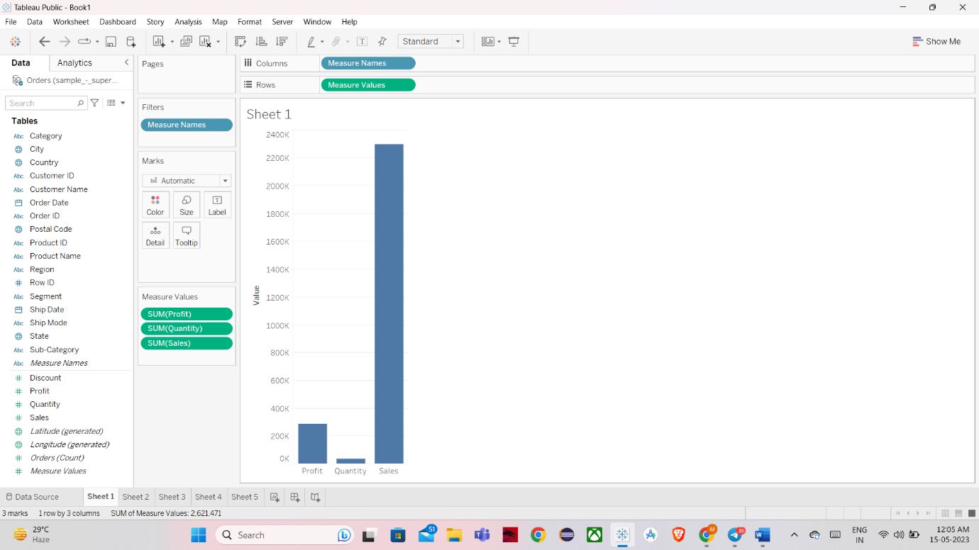QUESTION3

Question1

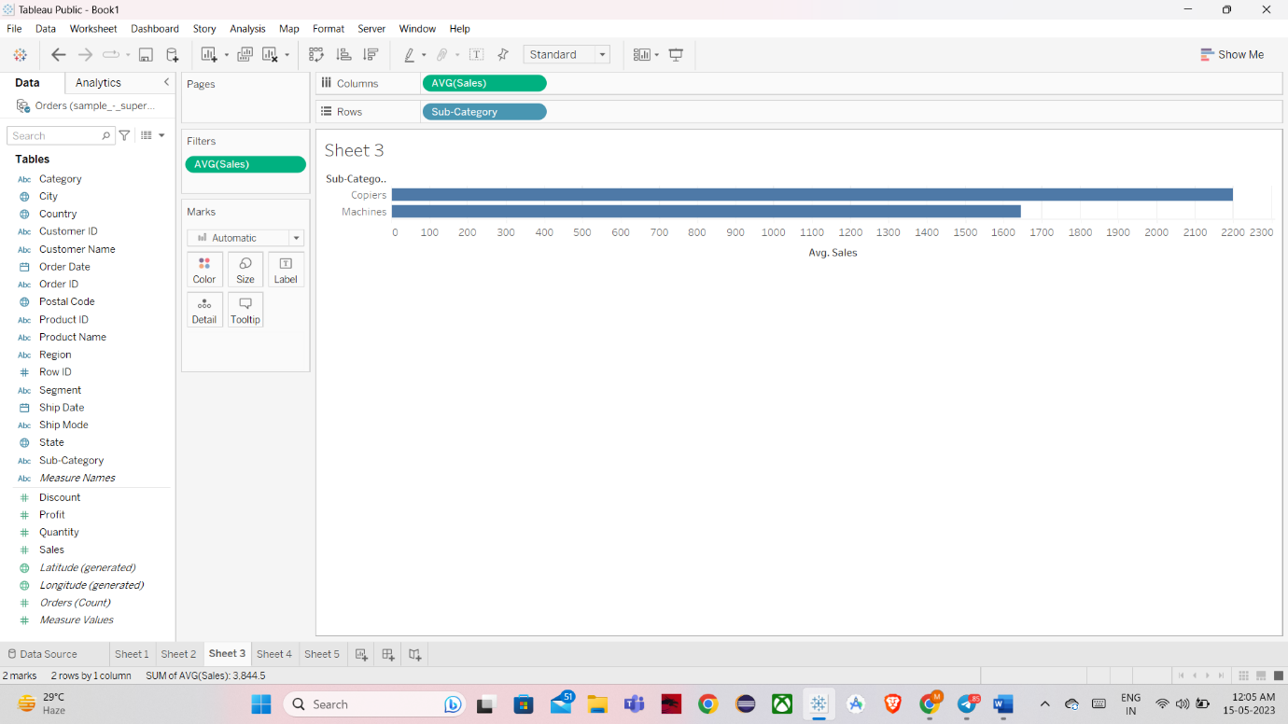

QUESTION5

QUESTION2QUESTION4

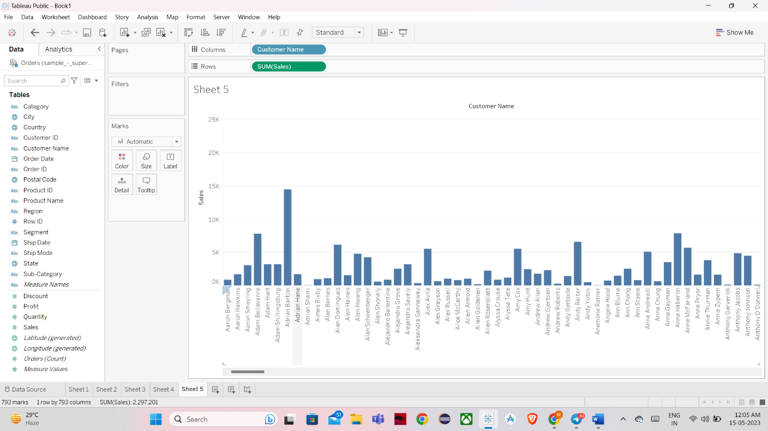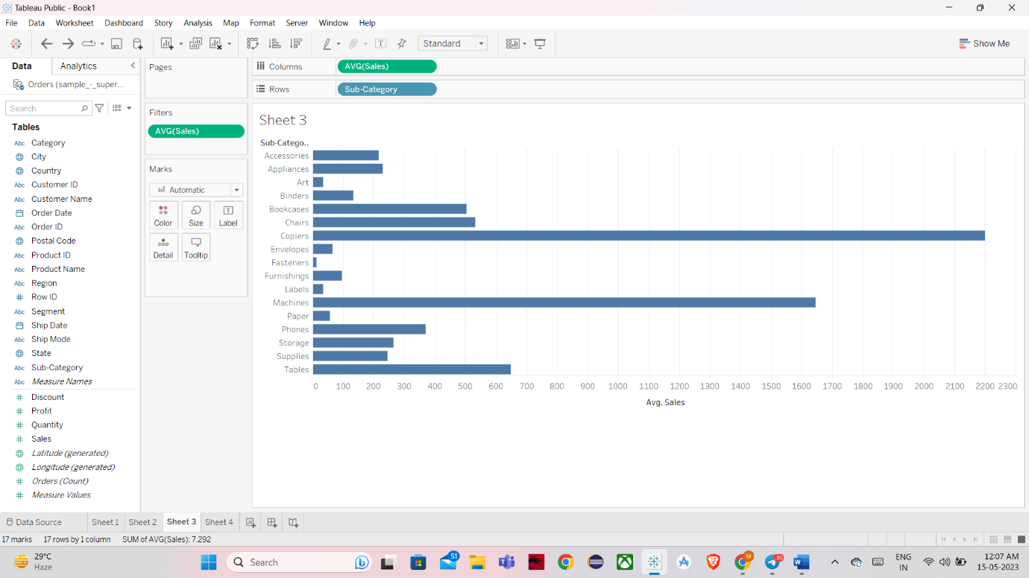QUESTION7